
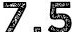
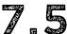
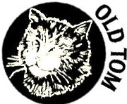
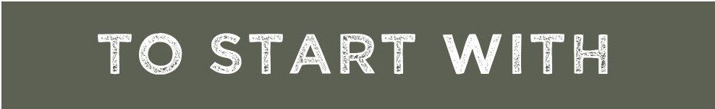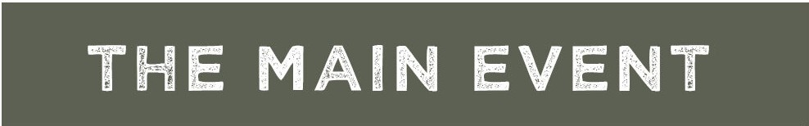
MUG0'
Soup of the day served with crispy garlic bread croutons.
SOUP">
P&W BLANKETS

Festive sausages wrapped in black treacle glazed bacon with a cranberry dip for dunkin'.
CAULI WINGS••---
Fried cauliflower florets glazed with a sticky honey, soy, garlic and ginger dressing; with pickled ginger and spring onions.
LETS TACO!, BOUT IT GF •-7m5
Shredded sprout and sweet potato soft shell taco with roasted corn, pickled red onion and chimmichuri sauce.
LET IT BRIE•7m5
Fig and honey baked brie served with goeey garlic bread for dunkin'.
BIRRIA NACHO SHARER GF _15
Tortilla chips loaded with shredded birria beef, gooey cheese, guacamole and salsa.
'RAISE THE STEAK' GF --
26
Skin-on-fries tossed in cranberry chimmichurri sauce and topped with a succulent 10oz ribeye steak and spicy cranberry jumbo prawns.
'OFF THE HOOK!, GF
16
Beer battered cod served with mushy pea and tartar drizzled skin-on-fries and a pot of gravy for dunkin'.
'THE CATS WHISKERS'
'Old Tom' X Beef Bourgignon - served with creamy mash and topped with crispy pancetta and silverskin onions.
18
THE OL' WINCHESTER •
16
Delicious 'Old Winchester' cheese and onion shortcrust pie served with creamy mash, buttered greens and lashings of gravy.
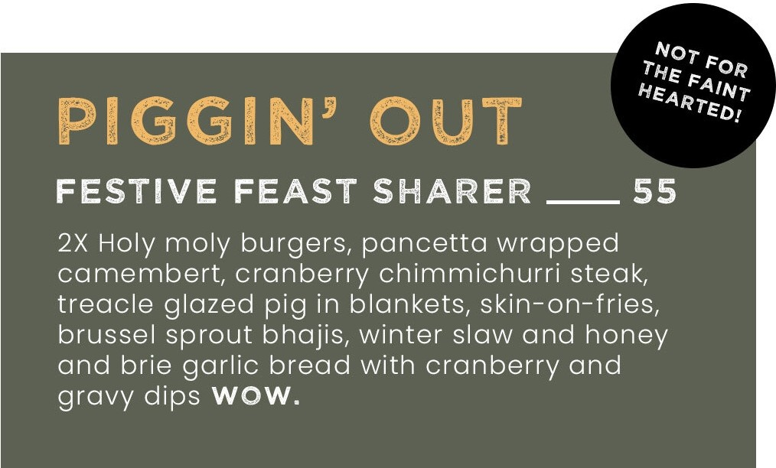

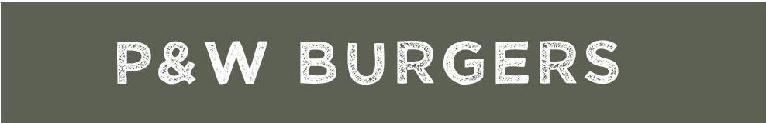
Crispy bacon, sausage, stuffing, cranberry and gravy.
BIRRIA BAD BOY
18
Beef burger topped with shredded birria beef, chopped onions, winter slaw and coriander and served in a brioche bun with a birria sauce dip for dunkin'.
HO HO HOLY MOLY18
Treacle glazed bacon, buttermilk chicken, brie and cranberry jam served in a brioche bun with a treacle glazed pig in blanket and gravy for dunkin'.
S-NO-W BURGER ••

16
Vegan burger with brussel sprout onion bhajis, curry mayo and coriander sauce in a burger bun with gravy for dunkin'.

*Served with skin-on-fries and P&W sprout slaw.
FESTIVE FRIES - 8
SKIN-ON-FRIES - 5 I MAC N CHEESE - 6
CREME DE LA CREME••-
Vanilla rice pudding torched with sugar and
6m5
ORANGE YOU GLAD •

6m5
topped with a strawberry and black pepper jam.
Creamy terrys chocolate orange cheesecake topped with whippy cream and chocolate pieces.
SUGAR AND SPICE•---
sticky toffee bread and butter pudding made with panettone and drizzled in sticky toffee sauce.
CHEESE'N'CHUTNEY
_
Cartmel cheese selection served with crackers, grapes, honey, and Hawkshead relish chutney.
p,V. ..q .
HEREjS THE SCOOP
Lakes luxury ice cream - ask your server for current flavours.q-" :
4m5
ALLERGENS -You must notify your server of any aIlergens - descriptions do not contain aII ingredients.

